




Success Story
September 2025

Planting the Future: A Success Story of Innovation in Kosovo’s MAP Sector

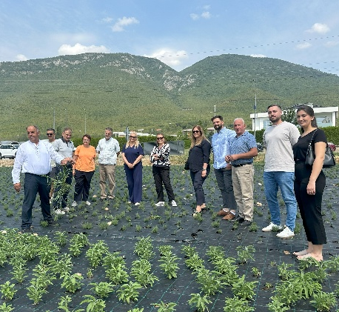
Kosovo’s MAPs sector is growing again
Farmers and advisors at a field day and training at Agropordukt shpk in Istog.

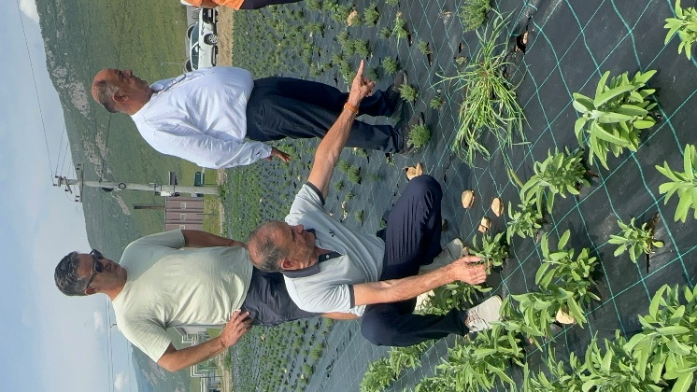
In western Kosovo, a new initiative is giving a renewed push to revitalize the country’s medicinal and aromatic plants (MAPs) sector.
Training in best-practices to MAPs farmers at a plot at Agropordukt shpk in Istog.
Through a strategic partnership between CNVP Kosovo, Organika Association, and leading exporter Agroprodukt shpk, the project is combining modern technology with traditional cultivation to help local farmers meet rising EU standards and reclaim their place in competitive markets.
Agroprodukt, Kosovo’s top MAPs exporter and leading seedling producer, works closely with a wide network of family farmers, while Organika supports the sector by providing advisory services, advocacy, and promoting sustainable practices.
The project is already building strong early momentum, with Agroprodukt supplying 450,000 organic seedlings and 150,000 of them already planted across two fully prepared 0.5-hectare plots, where an innovative agrotextile - used for the first time in Kosovo - alongside a full irrigation system installed to support healthy, organic development.
This joint effort is part of the SUNREED project, implemented by CNVP and funded by the Embassy of Sweden in Pristina (Sida). SUNREED supports the development of the Non-Wood Forest Products (NWFPs) and MAPs value chains by enhancing nurseries, improving cultivation and harvesting techniques, and upgrading post-harvest handling practices.
The MAPs sector in Kosovo has experienced a steep decline in recent years. The MAPs sector in Kosovo has experienced a steep decline in recent years. According to the Study of the Non-Wood Forest Products and Medical Aromatic Plants Sector – 2024 by the Organika Association, the area under cultivation dropped from 560 hectares in 2020 to just 200 hectares by 2023. One major reason is the reduced export potential to the EU, due to the detection of toxic compounds such as Pyrrolizidine Alkaloids (PAs) and Tropane Alkaloids (TAs) in harvested MAPs. EU Regulations impose strict limits on these substances in food products, including herbal teas.

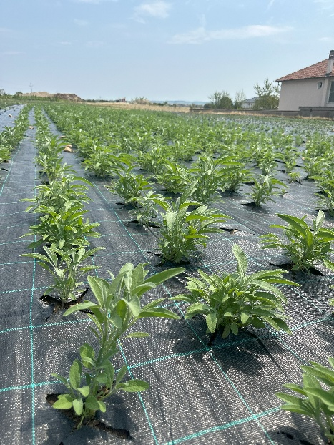
At the same time, the sector remains economically important. According to the study, approximately 2,000 farming households are engaged in MAP cultivation, while the processing sector supports around 300 full-time jobs and more than 1,000 seasonal positions.
SUNREED’s initiative is a direct response to these challenges.
In May 2025, six demonstration plots were established across the municipalities of Istog, Skenderaj and Novoberde. These plots feature well-known MAP species such as sage, thyme, savory, hyssop, lavender, mountain tea, and mint. They also stand out for the innovative way they’re being planted.
To date, 150,000 seedlings have already been successfully planted on two demonstration plots, with the remaining 300,000 will be planted during phase two in autumn 2025, using a newly introduced pneumatic sowing machine. This technology replaces traditional manual sowing, reduces seed waste, ensures precise planting, and lowers labor costs for farmers.
First-time use of agrotextile on the first MAP demonstration plot - an innovative fabric that suppresses weed growth and helps prevent contamination from PAs and TAs.
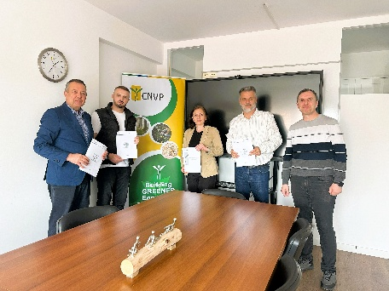
One of the most notable introductions in this project is the use of agrotextile - a technical fabric being applied for the first time by MAP farmers in Kosovo. Agrotextile helps suppress weed growth, retain soil moisture, regulates temperature, and prevents contamination by blocking contact between plants and soil particles that may carry PAs (Pyrrolizidine Alkaloids) and TAs (Tropane Alkaloids). In doing so, it directly tackles one of the biggest barriers to Kosovo’s MAP exports to the EU.
CNVP, Organika Association, and Agroproduct formalizing their partnership in April 2025 to strengthen the MAPs sector in Kosovo.
Between September and November 2025, preparations will begin on five additional plots (totaling 2.5 hectares) with six more farmers, expanding the reach of the project and continuing the same Throughout the process, farmers and advisors monitored progress closely, applying strict weed management practices to ensure the seedlings developed in a healthy, organic environment.
A key part of this support comes through advisory services, delivered by Organika’s team of newly trained, young advisors. These experts guide farmers in adopting best practices and addressing any challenges along the way.
To ensure wide-scale impact, the project includes field days, video documentation, and peer-to-peer learning opportunities, with the aim of reaching up to 200 additional farmers across Kosovo.

